|  |
| --- |
| **TIMETABLE, MESS MENU DISPLAYER AND FREE TIME CALCULATOR**  **21CSS101J – PROGRAMMING FOR PROBLEM SOLVING**  **Mini Project Report**  *Submitted by*  **Aman Anand [Reg. No.: RA2211003010130]**  **B.Tech. CSE Section B1**  **SRMIST-01.jpg**  **SCHOOL OF COMPUTING**  **COLLEGE OF ENGINEERING AND TECHNOLOGY**  **SRM INSTITUTE OF SCIENCE AND TECHNOLOGY**  **(Under Section 3 of UGC Act, 1956)**  S.R.M. NAGAR, KATTANKULATHUR – 603 203  KANCHEEPURAM DISTRICT  **December 2022** |

** COLLEGE OF ENGINEERING & TECHNOLOGY**

**SRM INSTITUTE OF SCIENCE & TECHNOLOGY**

**S.R.M. NAGAR, KATTANKULATHUR - 603203**

**Chengalpattu District**

**BONAFIDE CERTIFICATE**

**Register No___________RA2211003010130_______________**

Certified to be the bonafide work done by ______**Aman Anand**_______________ of I Year / I Sem B.Tech Degree course in **Programming for Problem Solving 21CSS101J** in **SRM INSTITUTE OF SCIENCE & TECHNOLOGY,** Kattankulathur during the academic year 2022-2023



**DATE : 20-12-2022 LAB INCHARGE**

Dr.A.Pandian

Associate Professor,

Dept. of CTECH



**TABLE OF CONTENTS**

|  |  |  |
| --- | --- | --- |
| **Chapter No.** | **Title** | **Page No.** |
| 1 | Problem Statement | 3 |
| 2 | Methodology / Procedure | 4 |
| 3 | Coding (C language) | 5-9 |
| 4 | Sample Input and Output | 10 |
| 5 | Conclusion | 11 |
|  |  |  |

**PROBLEM STATEMENT**

* Non existence of an online portal or program to tell the daily Timetable and Mess Menu, also calculator of Free Time during the Day

**Aim:** To write a C Program to tell the user daily mess menu and timetable and also daily free time

**Description:**

Students lead busy lives full of tests, assignments and coursework. This program is designed to make their lives more convenient. It is specially designed for SRMIST students. It tells them the timetable according to the day order and tells them the mess menu according to the day of the week. Just with a few clicks, the user can easily see the timetable and the menu. This saves the user the time to take out his batch timetable and match with his timetable. It also enables the user to see the mess menu without requiring to open his phone to see the photo captured of the menu. It will surely help save some time which can be utilized for some other thing. The students can utilize this time and plan their schedules accordingly. This program can further be integrated and expanded to tell the exam timetable, holidays list and so on. Also, if we tell the users the free time during the day, they can properly manage their time.

**Methodology/Procedure**

In this program, a main function is declared and two sub functions are formed to display mess menu and timetable.

This program first asks the user to input whether he wants to see the Timetable or the mess menu. Then, after analysing by if-else statement, it directs the user to messmenu() function or the timetable() function.

1] messmenu() function

This function asks the user to input the day of the week. Then, using switch case, to analyse this input, it tells the user the menu of breakfast, lunch, snacks and dinner.

2]timetable() function

This function asks the user to input the day order required. Then, analysing this input by switch case statement, it displays the day’s timetable.

3]timecalculator() function

This function asks the input of day order and sleeping time and displays the free time of the day.

This is the basic structure of the program.

**CODE**

***C Program:***

#include <stdio.h>  
int messmenu();  
int timetable();  
void timecalculator();  
// Mini-Project 1(Section-B1)  
int main()  
{  
  printf("Good Morning User, you have landed on the Timetable and Mess Menu Page.\n Press M to get mess menu and T to get Timetable");  
  char c;  
  scanf("%c", &c);  
  if (c == 'M')  
  {  
    messmenu();  
  }  
  else if (c == 'T')  
  {  
    timetable();  
  }  
  else  
  {  
    printf("You have entered wrong input\n");  
    main();  
    return 0;  
  }  
  }  
  int messmenu()  
  {  
    printf("Days of the week are:\n1-Monday\n2-Tuesday\n3-Wednesday\n4-Thursday\n5-Friday\n6-Saturday\n7-Sunday\n");  
    int operation;  
    printf("Enter day number (1,2,3,4,5,6,7):");  
    scanf("%d", &operation);  
    switch (operation)  
    {  
    case 1: // Monday  
      printf("Today's Menu is:\nBreakfast:\nBread, Butter, Jam, Vada, Chutney, Tea, Coffee\n\n");  
      printf("Lunch:\nMethi Chapati, Veg Topiaza Curry, Pancharatna Dal, Tomato Pulao, Steam Rice, Rasam, Buttermilk\n\n");  
      printf("Snacks:\nPavbhaji/Sweetbun, Tea, Coffee\n\n");  
      printf("Dinner:\nAtta Paratha, Chana Masala, Hara Moong dal, Idly, Chutney, Steam Rice, Sambar\n\n");  
  
      break;  
  
    case 2: // Tuesday  
      printf("Today's Menu is:\nBreakfast:\nBread, Butter, Jam, Poori, Potato Masala, Tea, Coffee\n\n");  
      printf("Lunch:\nSweet, Chapati, Meal Maker Curry, Pancharatna Dal, Tomato Pulao, Steam Rice, Rasam, Buttermilk\n\n");  
      printf("Snacks:\nBonda/Keerai vada, Tea, Coffee\n\n");  
      printf("Dinner:\nPunjabi Paratha, White Korma, Dal Makhani, Rasam, Steam Rice, Sambar\n");  
  
      break;  
  
    case 3: // Wednesday  
      printf("Today's Menu is:\nBreakfast: Bread, Butter, Jam, Omlette, Poha, Dosa, Sambar, Tea, Coffee\n\n");  
      printf("Lunch: Poori, Aloo Kara Curry, Sambar Dal, Tomato Pulao, Veg Pulao/Steam Rice, Garlic Rasam, Buttermilk\n\n");  
      printf("Snacks:\nVeg Puff/SweetPuff, Tea, Coffee\n\n");  
      printf("Dinner:\nChapati, Butter chicken, Paneer Butter masala, Dal, Rice \n");  
  
      break;  
  
    case 4: // Thursday  
      printf("Today's Menu is:\nBreakfast:\nBread, Butter, Veg Semiya, Aloo Rajma, Chapathi, Tea, Coffee\n\n");  
      printf("Lunch:\nMint Chapathi, White Korma, Aloo Gobi Masala, Steam Rice, Rasam, Buttermilk\n\n");  
      printf("Snacks:\nBajji, Tea, Coffee\n\n");  
      printf("Dinner:\nMadras Paratha, Mutter Paneer Masala, Dal Tadka, Dosa, Idly, Chutney, Steam Rice, Sambar\n");  
  
      break;  
    case 5: // Friday  
      printf("Today's Menu is:\nBreakfast:\nBread, Butter, Chole Dal, Aloo Masala, Chapathi, Tea, Coffee\n\n");  
      printf("Lunch:\nSweet, Chapathi, Aloo Mutter Masala, Maisoore Dal, Steam Rice, Rasam, Buttermilk\n\n");  
      printf("Snacks:\nCake, Tea, Coffee\n\n");  
      printf("Dinner:\nVeg Manchurian, Veg Noodles, Rasam, Steam Rice, Sambar\n");  
  
      break;  
    case 6:  
      printf("Today's Menu is:\nBreakfast:\nBread, Butter,Veg Korma, Chapathi, Boiled Egg, Tea, Coffee\n\n");  
      printf("Lunch:\nPoori, White Peas Curry, Aloo Bindli Sabji, Steam Rice, Rasam, Buttermilk\n\n");  
      printf("Snacks:\nPakoda, Tea, Coffee\n\n");  
      printf("Dinner:\nPunjabi Paratha, Aloo Capsicum Subji, Masala Dal, Idly, Chutney, Steam Rice, Sambar\n");  
  
      break;  
  
    case 7:  
      printf("Today's Menu is:\nBreakfast:\nBread, Butter, Chole Bhature, Tea, Coffee\n\n");  
      printf("Lunch:\nChapati, Chicken Pepper, Paneer Butter Masala , Steam Rice, Rasam, Buttermilk\n\n");  
      printf("Snacks:\nSamosa/Aloo Bonda, Tea, Coffee\n\n");  
      printf("Dinner:\nAloo Paratha, Chole Gobi Curry, Hara Moong Dal, Karakozhambu, Steam Rice, Sambar\n");  
  
      break;  
  
    default:  
      printf("Invalid Input");  
    }  
    int n;  
    printf("Enter 1 to check free time");  
    scanf("%d",&n);  
    if(n==1){  
        timecalculator();  
    }  
    else{  
        printf("Invalid Input");  
    }  
    return 0;  
  }  
  int timetable()  
  {  
    int operation;  
    printf("Enter day order (1,2,3,4,5):");  
    scanf("%d", &operation);  
    switch (operation)  
    {  
    case 1: // Day Order-1  
      printf("Hello User,your today schedule is:\n");  
      printf("09:45 to 11.30 - Programming for Problem Solving (Theory)\n");  
      printf("15:15 to 16:55 - Programming for Problem Solving (Lab)\n");  
      printf(" \n");  
      printf("Have a good day...");  
      break;  
  
    case 2: // Day Order-2  
      printf("Hello User,your today schedule is:\n");  
      printf("08:00 to 11.30 - Basic Mechanical and Civil Workshop\n");  
      printf("12:30 to 14:15 - Calculus and Linear Algebra (Theory)\n");  
      printf(" \n");  
      printf("Have a good day...");  
      break;  
  
    case 3: // Day Order-3  
      printf("Hello User,your today schedule is:\n");  
      printf("08:00 to 09:40 - Introduction to Computational Biology (Theory)\n");  
      printf("10:40 to 11:30 - Chemistry (Theory)\n");  
      printf("11:35 to 12:25 - Calculus and Linear Algebra (Theory)\n");  
      printf("13:25 to 15:10 - Professional Skills and Practices (Lab)\n");  
      printf("15:15 to 16:55 - NSS (Lab)\n");  
      printf(" \n");  
      printf("Have a good day...");  
      break;  
  
    case 4: // Day Order-4  
      printf("Hello User,your today schedule is:\n");  
      printf("09:45 to 11:30 - Philosophy of Engineering (Lab)\n");  
      printf("12:30 to 14:15 - Chemistry (Theory)\n");  
      printf("14:20 to 15:10 - Calculus and Linear Algebra (Theory)\n");  
      printf("15:15 to 16:05 - French (Theory)\n");  
      printf("16:05 to 16:55 - Introduction to Computational Biology (Theory)\n");  
      printf(" \n");  
      printf("Have a good day...");  
      break;  
    case 5: // Day Order-5  
      printf("Hello User,your today schedule is:\n");  
      printf("08:00 to 09:40 - French (Theory)\n");  
      printf("09:45 to 10:35 - Introduction to Computational Biology (Theory)\n");  
      printf("10:40 to 11:30 - Programming for Problem Solving (Theory)\n");  
      printf("11:35 to 12:25 - Chemistry (Theory)\n");  
      printf("13:25 to 15:10 - Chemistry (Lab)\n");  
      printf(" \n");  
      printf("Have a good day...");  
      break;  
  
    default:  
      printf("Invalid Input");  
    }  
     int n;  
    printf("Enter 1 to check free time");  
    scanf("%d",&n);  
    if(n==1){  
        timecalculator();  
    }  
    else{  
        printf("Invalid Input");  
    }  
    return 0;  
  }  
   
 void timecalculator(){  
     printf("Considering, That you take 15 minutes per meal, you will spend 1 hour in mess per day. Now select the day order to check how much time you will spend in classes and mess combined and then let us calculate your free time for better time management\n");  
     int a;  
     printf("Enter day order");  
     scanf("%d",&a);  
     switch(a)  
     {  
         case 1: ;  
         float mess= 1;  
         float classes=3.33;  
         printf("Time spent in classes: %0.2f hours\n",classes);  
         printf("Time spent in mess: 1 hours\n");  
         float sleep;  
         printf("Enter Sleeping Duration in hours:");  
         scanf("%f",&sleep);  
         float freetime=24-(mess+classes+sleep);  
         printf("Your free time for the day is: %0.2f hours",freetime);  
         break;  
           
         case 2: ;  
         mess= 1;  
         classes=5;  
         printf("Time spent in classes: %0.2f hours\n",classes);  
         printf("Time spent in mess: 1 hours\n");  
         sleep;  
         printf("Enter Sleeping Duration in hours:");  
         scanf("%f",&sleep);  
         freetime=24-(mess+classes+sleep);  
         printf("Your free time for the day is: %0.2f hours",freetime);  
         break;  
           
         case 3: ;  
         mess= 1;  
         classes=6.66;  
         printf("Time spent in classes: %0.2f hours\n",classes);  
         printf("Time spent in mess: 1 hours\n");  
         sleep;  
         printf("Enter Sleeping Duration in hours:");  
         scanf("%f",&sleep);  
         freetime=24-(mess+classes+sleep);  
         printf("Your free time for the day is: %0.2f hours",freetime);  
         break;  
           
         case 4: ;  
         mess= 1;  
         classes=5.83;  
         printf("Time spent in classes: %0.2f hours\n",classes);  
         printf("Time spent in mess: 1 hours\n");  
         sleep;  
         printf("Enter Sleeping Duration in hours:");  
         scanf("%f",&sleep);  
         freetime=24-(mess+classes+sleep);  
         printf("Your free time for the day is: %0.2f hours",freetime);  
         break;  
           
         case 5: ;  
         mess= 1;  
         classes=5.83;  
         printf("Time spent in classes: %0.2f hours\n",classes);  
         printf("Time spent in mess: 1 hours\n");  
         sleep;  
         printf("Enter Sleeping Duration in hours:");  
         scanf("%f",&sleep);  
         freetime=24-(mess+classes+sleep);  
         printf("Your free time for the day is: %0.2f hours",freetime);  
         break;  
     }  
  
 }

**SAMPLE INPUT AND OUTPUT**

1] TimeTable Sample Input and Output

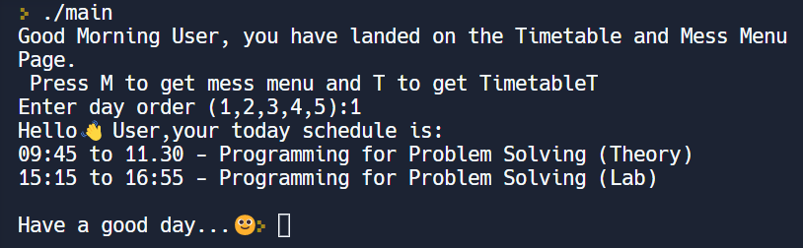

2] Mess Menu Sample Input and Output

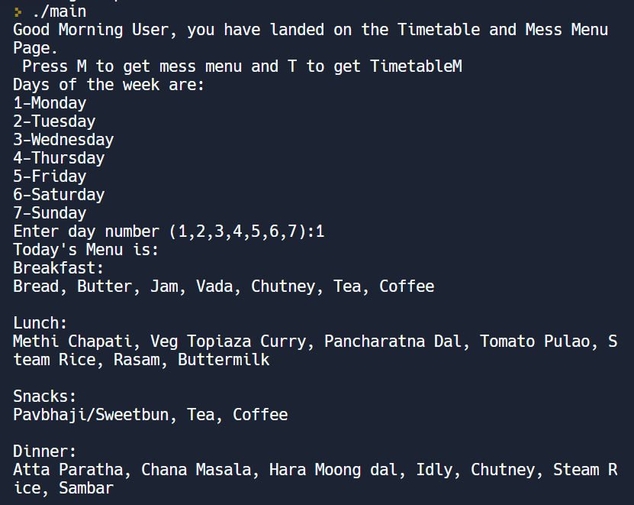

3] Free Time calculation

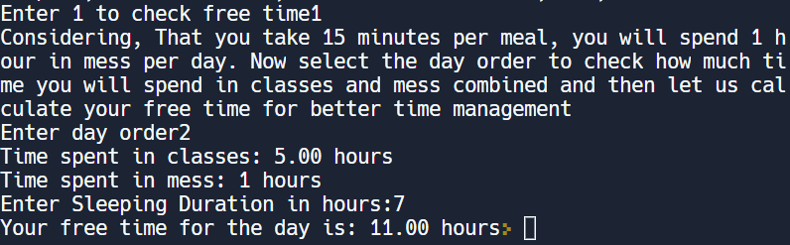

**Conclusion**

This program was found to be successfully giving the user the intended output. It immensely helped the user to save the time and met all expectations of the user. It was tested on some of the target audience i.e.- students and was found to be quite popular. Thus the aim of the project is achieved.